AIMS Guard Accountability Trigger Framework (ATF)

Version 0.1

A Governance Framework for Human Oversight and High-Risk AI Decisions

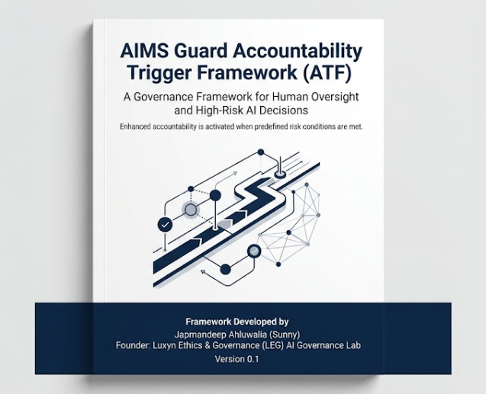

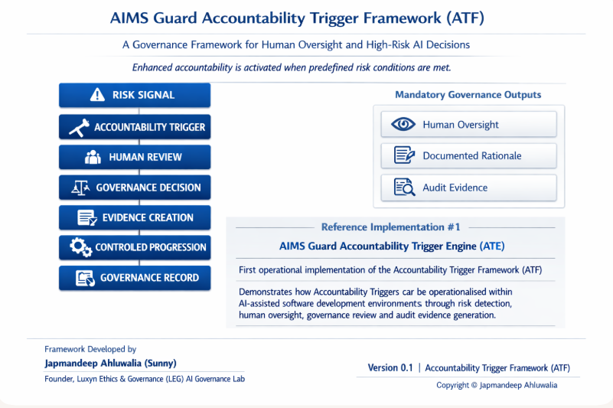

1. Problem Statement

2. Core Concept: Accountability Triggers

3. Framework Principles

4. Governance Lifecycle

5. Evidence Generation

6. Reference Implementations

7. Future Applications

8. Limitations

9. Conclusion

- Problem Statement

- Organisations are increasingly using AI-assisted systems to support decisions, generate content, write code, automate workflows and perform operational tasks.

- Many governance frameworks describe principles such as accountability, transparency and human oversight, but organisations often struggle to translate those principles into practical controls.

- A recurring challenge is determining when a decision, action or change should require additional scrutiny.

- The AIMS Guard Accountability Trigger Framework (ATF) proposes a simple approach: predefined risk conditions should activate an Accountability Trigger that requires governance intervention before progression can continue.

- The framework focuses on creating observable accountability through human oversight, documented rationale and evidence generation.

- Core Concept: Accountability Triggers

An Accountability Trigger is a governance mechanism that activates when predefined risk conditions are met.

The purpose of an Accountability Trigger is not to prevent action, but to ensure that potentially significant decisions, changes or outcomes receive appropriate review before progression continues.

When an Accountability Trigger is activated, three governance requirements become mandatory:

1. Human Oversight
2. Documented Rationale
3. Evidence Generation

The framework is technology agnostic and can be applied across different domains. AI-assisted software development is the first reference implementation, but the concept can also be applied to AI systems, automated decision-making, public sector processes, healthcare, financial services and other high-impact environments.

The central proposition of the framework is that accountability should not depend solely on policy documents. It should be activated through observable governance controls that create reviewable evidence.

- Framework Principles

3.1 Risk Signal Detection: Risk Signal Detection is the process of identifying events, actions, decisions or changes that may create governance, safety, compliance, security or accountability concerns.

Risk signals may be defined through policies, rules, thresholds, classifications or contextual factors relevant to the operating environment.

The objective is to identify situations that warrant additional governance attention before progression continues.

3.2 Accountability Trigger Activation: Accountability Trigger Activation occurs when a predefined risk signal meets the conditions for governance intervention.

The trigger acts as a formal governance checkpoint. It converts a potential concern into an observable governance event requiring review.

The trigger does not determine the outcome. Its purpose is to ensure that the event receives appropriate scrutiny before progression continues.

3.3 Human Oversight: Human Oversight ensures that accountability remains attached to identifiable individuals rather than being delegated entirely to automated systems.

When an Accountability Trigger is activated, an appropriately authorised person should review the situation before progression continues.

The purpose of oversight is not to replace automation. It is to provide judgement, context and responsibility in situations where predefined risk conditions have been met.

The reviewer should have sufficient authority, knowledge and independence to assess the circumstances and determine whether progression, modification, escalation or rejection is appropriate.

3.4 Governance Decision Capture: Governance Decision Capture records the outcome of the review process and the reasoning that supports it.

The framework assumes that accountability is difficult to demonstrate if decisions are not documented.

At a minimum, the governance record should identify the decision taken, the responsible reviewer and the rationale supporting the outcome.

Decision capture creates transparency and allows future reviewers, auditors and stakeholders to understand how and why a governance decision was reached.

3.5 Evidence Generation: Evidence Generation creates a verifiable record that an Accountability Trigger occurred, that governance review was performed and that a decision was reached.

The objective is to make accountability observable rather than assumed.

Evidence may include audit records, review comments, approval records, supporting documentation, timestamps, workflow outputs or other artefacts relevant to the operating environment.

The form of evidence may vary across organisations and use cases, but the principle remains consistent: governance activities should leave a reviewable trail that supports transparency, assurance and future investigation when required.

3.6 Controlled Progression: Controlled Progression ensures that activities subject to an Accountability Trigger cannot continue until the required governance actions have been completed.

The purpose is not to create unnecessary friction. The purpose is to prevent significant actions, decisions or changes from bypassing established governance controls.

Once the required review, decision capture and evidence generation activities have been completed, progression may continue in accordance with organisational policies and delegated authorities.

Controlled Progression provides a practical mechanism for translating governance requirements into operational behaviour.

- Governance Lifecycle

4.1 Risk Signal: The Governance Lifecycle begins with the identification of a Risk Signal.

A Risk Signal is an event, action, decision, change or condition that may introduce governance, accountability, compliance, safety, security or operational concerns.

Risk Signals may be identified through policies, rules, thresholds, monitoring activities, classifications or contextual assessment.

The purpose of a Risk Signal is not to determine whether a problem exists. Its purpose is to identify situations that may require additional governance attention.

4.2 Accountability Trigger: When predefined conditions are met, an Accountability Trigger is activated.

The trigger serves as a formal governance checkpoint. It converts a potential concern into an observable governance event requiring review.

An Accountability Trigger does not determine the outcome. It ensures that the event receives appropriate scrutiny before progression continues.

4.3 Human Review: Following trigger activation, responsibility is assigned to an appropriate reviewer.

The reviewer assesses the circumstances, available evidence, potential impacts and applicable governance requirements.

Human Review introduces judgement, context and accountability into situations where predefined risk conditions have been met.

4.4 Governance Decision: The reviewer reaches a governance decision based on the information available.

Possible outcomes may include approval, rejection, modification, escalation or requests for additional information.

The decision should be proportionate to the level of risk and aligned with organisational policies, responsibilities and delegated authorities.

4.5 Evidence Creation: The governance process generates evidence that the review occurred and that a decision was reached.

Evidence may include audit records, approvals, comments, workflow outputs, supporting documentation, timestamps or other relevant artefacts.

Evidence Creation transforms governance activity into a reviewable and verifiable record.

4.6 Controlled Progression: Activities subject to an Accountability Trigger should not progress until the required governance actions have been completed.

Controlled Progression ensures that governance requirements are applied consistently and cannot be bypassed unintentionally.

Once the required controls have been satisfied, progression may continue in accordance with organisational policies.

4.7 Governance Record: The final output of the Governance Lifecycle is a Governance Record.

The Governance Record provides a traceable account of the Risk Signal, Trigger Activation, Review Activity, Governance Decision and supporting evidence.

This record supports transparency, accountability, assurance activities and future review when required.

- Evidence Generation

5.1 Why Evidence Matters: Governance activities are often difficult to assess after the event if no evidence exists to demonstrate what occurred, who was involved and how decisions were reached.

The Accountability Trigger Framework assumes that accountability cannot rely solely on policies, intentions or verbal assurances. Governance activities should generate evidence that can be reviewed, verified and understood by relevant stakeholders.

Evidence supports transparency, internal assurance, audit activities, investigations, organisational learning and continuous improvement.

The objective is not to create documentation for its own sake. The objective is to ensure that governance decisions remain observable and traceable when required.

5.2 Types of Governance Evidence: Governance Evidence may take different forms depending on the operating environment.

Examples include:

• Review records
• Approval records
• Audit logs
• Workflow outputs
• Governance comments
• Decision records
• Supporting documentation
• Escalation records
• Timestamps and activity logs

The framework does not prescribe a single evidence format. Organisations should determine the evidence most appropriate to their governance requirements, risk profile and regulatory obligations.

5.3 Minimum Evidence Requirements: The Accountability Trigger Framework does not prescribe a single evidence standard. However, every Accountability Trigger should generate sufficient information to demonstrate that governance intervention occurred.

As a minimum, evidence should identify:

• The Risk Signal that initiated review
• The Accountability Trigger that was activated
• The responsible reviewer or decision maker
• The governance decision reached
• The date and time of the decision

Additional evidence may be required depending on organisational policies, regulatory obligations and risk levels.

  - Evidence Integrity: Evidence should be created, stored and maintained in a manner that preserves confidence in its authenticity, traceability and reliability.

Individuals responsible for governance activities should be able to demonstrate that evidence accurately reflects the events, reviews and decisions that occurred.
Organisations should implement controls appropriate to their operating environment to reduce the risk of unauthorised modification, deletion or misrepresentation of governance records.

The Accountability Trigger Framework does not prescribe specific technical mechanisms. However, the framework assumes that governance evidence should remain attributable, reviewable and sufficiently trustworthy to support assurance, audit and investigative activities when required.

5.5 Evidence Retention: Governance evidence should be retained for a period appropriate to organisational requirements, legal obligations and risk considerations.

Retention periods may vary depending on the nature of the activity, industry requirements and applicable regulations.

The framework does not mandate specific retention periods. Instead, it requires organisations to establish retention practices that support accountability, review, assurance activities and future investigation when necessary.

Evidence that cannot be retrieved when required provides limited accountability value.

- Reference Implementations:

6.1 AIMS Guard Accountability Trigger Engine (ATE): The AIMS Guard Accountability Trigger Engine (ATE) is the first reference implementation of the Accountability Trigger Framework.

ATE was developed to demonstrate how Accountability Triggers can be operationalised within AI-assisted software development environments.

The implementation applies the core concepts of the framework by identifying predefined risk signals, activating Accountability Triggers, requiring human oversight, generating governance evidence and controlling progression until governance requirements have been satisfied.

ATE was intentionally designed as a practical demonstration rather than a comprehensive governance platform. Its purpose is to show how governance principles can be translated into observable controls within a real operational workflow.

The project provides a public example of how accountability, human oversight and evidence generation can be embedded into development processes through lightweight governance mechanisms.

6.2 AI-Assisted Software Development: AI-assisted software development presents a practical environment in which Accountability Triggers can be applied.

Modern development teams increasingly use AI systems to generate code, modify workflows, recommend changes and automate development activities.

While these capabilities can increase productivity, they may also introduce changes affecting security, infrastructure, compliance, governance controls and operational reliability.

Within this environment, Accountability Triggers can be used to identify predefined high-risk conditions and ensure that enhanced governance activities occur before progression continues.

The objective is not to restrict innovation. The objective is to ensure that significant changes remain visible, reviewable and accountable.

6.3 Future Implementations: The Accountability Trigger Framework is intended to be technology agnostic and applicable across multiple domains.

Potential future implementations may include healthcare systems, public sector decision-making, financial services, autonomous systems, AI procurement processes, compliance workflows and other environments involving high-impact decisions.

While implementation approaches may differ between domains, the underlying framework remains consistent.

Risk Signals activate Accountability Triggers, Accountability Triggers require governance intervention and governance activities generate evidence that supports accountability.

Future implementations should adapt the framework to their specific operational, regulatory and governance requirements.

- Future Applications

7.1 Public Sector AI: Potential examples include AI-assisted eligibility assessments, public housing allocation processes, benefits administration, case management workflows and other public services where decisions may have significant consequences for individuals and communities.
In such environments, Accountability Triggers may help ensure that predefined high-risk conditions receive appropriate human review, governance scrutiny and evidence-based decision support before progression continues.

7.2 Healthcare and Regulated Environments: Healthcare and other regulated environments often involve decisions with significant human, legal, financial or operational consequences.

In such settings, Accountability Triggers may support governance processes by identifying situations that require enhanced review, escalation or documented decision-making.

The framework does not replace clinical judgement, professional responsibility or regulatory requirements. Instead, it provides a mechanism for ensuring that predefined risk conditions activate appropriate governance interventions.

The objective is to support accountable decision-making while maintaining traceable evidence of governance activities.

7.3 Autonomous and Agentic Systems: As autonomous and agentic systems become more capable, organisations may require additional mechanisms to determine when automated activities should receive human review.

The Accountability Trigger Framework provides a model in which predefined conditions activate governance checkpoints before certain actions, decisions or outcomes are allowed to progress.

The framework does not assume that all autonomous activity requires intervention. Instead, it focuses on identifying circumstances where enhanced accountability becomes necessary.

This approach seeks to balance operational efficiency with responsible oversight.

7.4 Organisational Governance Workflows: Many governance processes rely on manual reviews, approvals and procedural controls that may be difficult to apply consistently at scale.

The Accountability Trigger Framework provides a structured method for introducing risk-based governance interventions into operational workflows.

By defining Risk Signals, Trigger Conditions, Review Requirements and Evidence Expectations, organisations can create more consistent and observable governance processes.

The framework is intended to complement existing governance structures rather than replace them.

- Limitations:

The Accountability Trigger Framework is intended as a governance model and not as a regulatory, legal or certification framework.

The framework does not guarantee compliance with any specific law, regulation, standard or certification requirement.

Implementation effectiveness depends on organisational culture, governance maturity, risk definitions, reviewer competence and operational controls.

The framework also does not determine which decisions should be made. Its purpose is to provide a structured mechanism for ensuring that predefined risk conditions receive appropriate governance attention.

Organisations adopting the framework should adapt it to their specific operational, legal, regulatory and governance requirements.

- Conclusion:

The Accountability Trigger Framework proposes a practical approach to operationalising accountability within complex and increasingly automated environments.

The framework is based on a simple principle: enhanced accountability should be activated when predefined risk conditions are met.

By combining Risk Signal Detection, Accountability Trigger Activation, Human Oversight, Governance Decision Capture, Evidence Generation and Controlled Progression, the framework seeks to transform accountability from a policy objective into an observable governance activity.

The AIMS Guard Accountability Trigger Engine represents the first reference implementation of the framework and demonstrates how these concepts can be translated into practical controls within AI-assisted software development environments.

Future implementations may extend the framework into additional domains where accountable decision-making, human oversight and evidence generation are important governance objectives.

